**Functional Requirement Document**

## Find travel insurance plan for students

**Submitted to**

**Cognizant Technology Solutions**

**Submitted by**

N V Harini (899606)

Susheel Sharma (899596)

Haleema Sadiya S (899565)

Nilofer Fathima (899547)

V Geetha Naga Sripriya (899619)

**For more information please visit on website:**

<http://www.policybazaar.com>

**Date of Submission**

April 2021.

**FUNCTIONAL SPECIFICATIONS DOCUMENTATION**

**Hack O’ Holics**

**APRIL 2021**

**Version 1.0.0**

| VERSION HISTORY | | | | |
| --- | --- | --- | --- | --- |
| VERSION | APPROVED BY | REVISION DATE | DESCRIPTION OF CHANGE | AUTHOR |
|  |  |  |  |  |
|  |  |  |  |  |
|  |  |  |  |  |
|  |  |  |  |  |
|  |  |  |  |  |
|  |  |  |  |  |
|  |  |  |  |  |

**Functional Specifications Document**

**Authorization Memorandum**

I have carefully assessed the Functional Specifications Document for the

## Find travel insurance plan for students.

MANAGEMENT CERTIFICATION - Please check the appropriate statement.

______ the document is accepted.

______ the document is accepted pending the changes noted.

______ the document is not accepted.

We fully accept the changes as needed improvements and authorize initiation

of work to proceed. Based on our authority and judgment, the continued

operation of this system is authorized.

_______________________________ _____________________

NAME DATE

Project Manager

_______________________________ _____________________

NAME DATE

Director

*Add other names and roles as necessary.*

TABLE OF CONTENTS

1.0 INTRODUCTION 4

1.1 Purpose 4

1.2 Abbreviations and Acronyms 4

1.3 Refrences 4

1.4 Document conventions 4

2.0 GENERAL DESCRIPTION 5

2.1 Product Context 5

2.2 User Classes and Characteristics 5

2.3 Overview of Functional Requirements 6

2.4 Overview of Data Requirements 6

2.5 Operating Environment 7

2.6 General Constraints, Assumptions, Dependencies, Guidelines 7

2.7 Design and Implementation Constraints 7

2.8 User Documentation 7

3.0 REQUIREMENTS 8

3.1 External Interface Requirements 8

3.1.1 User Interfaces 8

3.1.2 Hardware Interfaces 8

3.1.3 Software Interfaces 8

3.1.4 Communications Interfaces 9

3.2 Functional Requirements 9

3.2.1 Template for functional requirements 9

3.3 Performance Requirements 15

3.4 Security 15

3.5 Usability 15

3.6 Other Requirements 15

Appendix A. Analysis Models 17

Appendix B. Issues List 21

**1.0. INTRODUCTION**

## 1.1. Purpose

PolicyBazaar is an [Indian](https://en.wikipedia.org/wiki/List_of_companies_of_India) Insurance company founded in 2008. Headquartered in Gurgaon, India. The company provides Insurance services including Life Insurance, Investment Plans, Health Insurance, Motor Insurance and Other Insurance.

**1.2. Abbreviations and Acronyms**

* HTML- Hyper Text Markup Language
* CSS -Cascading Style Sheets
* RAM - Random Access Memory.
* GB - Giga Bytes.
* HTTP –Hyper Text Transfer Protocol

**1.3. References**

<https://www.guru99.com/functional-requirement->

specification- example.html

**1.4. Document conventions**

Bold faced text has been used to emphasise headings and

subheadings. Arial font has been used with headings of size 16

and subheadings of size 14 and the description with12.

# 2.0. GENERAL DESCRIPTION

## 2.1. Product Context

PolicyBazaar website’s main function is to provide best Insurance Service and Investment Plans. It also provide a wide range of Insurance packages regarding Travel, Life, Motor, Health and their updates. It contains different Insurance packages which make client feel more secure and comfortable.

## 2.2. User Classes and Characteristics

These are the users who will be interested in PolicyBazaar website.

|  |  |  |  |
| --- | --- | --- | --- |
| **S.NO** | **NAME OF USERS** | **ROLE** | **CHARCTERSTICS** |
| 1 | Super Users | Authorized **PolicyBazaar** staff that is responsible for administering, supporting and maintaining the PolicyBazaar website. | Uses the website to configure and troubleshoot the behavior of website. |
| 2 | Administrators | Authorized staff who are responsible for reporting on and administering the data present in PolicyBazaar website. | Uses the website to perform day-to-day reporting and administrative work to maintain the running state of website. |
| 3 | System Users | Users with or without their accounts can use this website. | Uses website to check various Insurance Plans such as Travel, Motor, Health, their price, etc. |

## 2.3. Overview of Functional Requirements

1. Click on Insurance Plan.
2. Select Travel Insurance.
3. Click on Student Tab
4. Enter the details of functionalities.
5. Proceed Button
6. Enter the details
7. Get Free Quotes Button
8. Click on Sort By.
9. Select Price Low-High.
10. Back to Home Page
11. Select Car Insurance.
12. Proceed without Car Number Button.
13. Enter the details
14. View Prices Button
15. Capture Error Message
16. Back to Home Page
17. Select Health Insurance.
18. Display Health Insurance Plan.

**2.4. Overview of Data Requirements**

* **Input value**: input data should be from different sources.
* **Static value**: a static application or system is required for automation.
* **Output**: expected output data is preferred.

**2.5. Operating Environment**

* **Processor**: Intel core
* **RAM:** 8 GB
* **OS**: windows 10

## 2.6. General Constraints, Assumptions, Dependencies, m

## Guidelines

Each user has an account. Each user has to login using valid credentials. No user can share their login credentials.

## 2.7. Design and Implementation Constraints

* The application has used HTML, CSS, and java script as main technologies.
* HTTP protocols are used to access the web application.
* Since PolicyBazaar is a web based application, internet connection must be established.
* This web application runs on different browsers.

**2.8. User Documentation**

There are no user manuals, online helps as it is easily understood.

# 3.0. REQUIREMENTS

## 3.1. External Interface Requirements

### 3.1.1. User Interfaces

* All users will see the same page when they enter in this web site.
* When a user tries to login, this page asks Mobile number and OTP.
* After being authenticated by Mobile number and OTP, user will be directed to their corresponding profile.
* The user interface is simple and easy to understand the terminology.

### 3.1.2. Hardware Interfaces

* No extra hardware interfaces are needed.
* The system will use standard hardware and data communication resources.

### 3.1.3. Software Interfaces

* **Os**: windows 10
* **Web browser**: The system is a web based application; clients need any web browser such as chrome, Firefox, opera, internet explorer. The computer must have an internet connection in order to access with the system.

### 3.1.4. Communications Interfaces

* This system uses communication resources which includes HTTP protocol for communication with web bro and TCP/IP network protocol with HTTP protocol.

## 3.2. Functional Requirements

## 3.2.1. Template for functional requirements

**a.** Click on Insurance Plan.

**Input:** click on login

**Output:** navigate to next page.

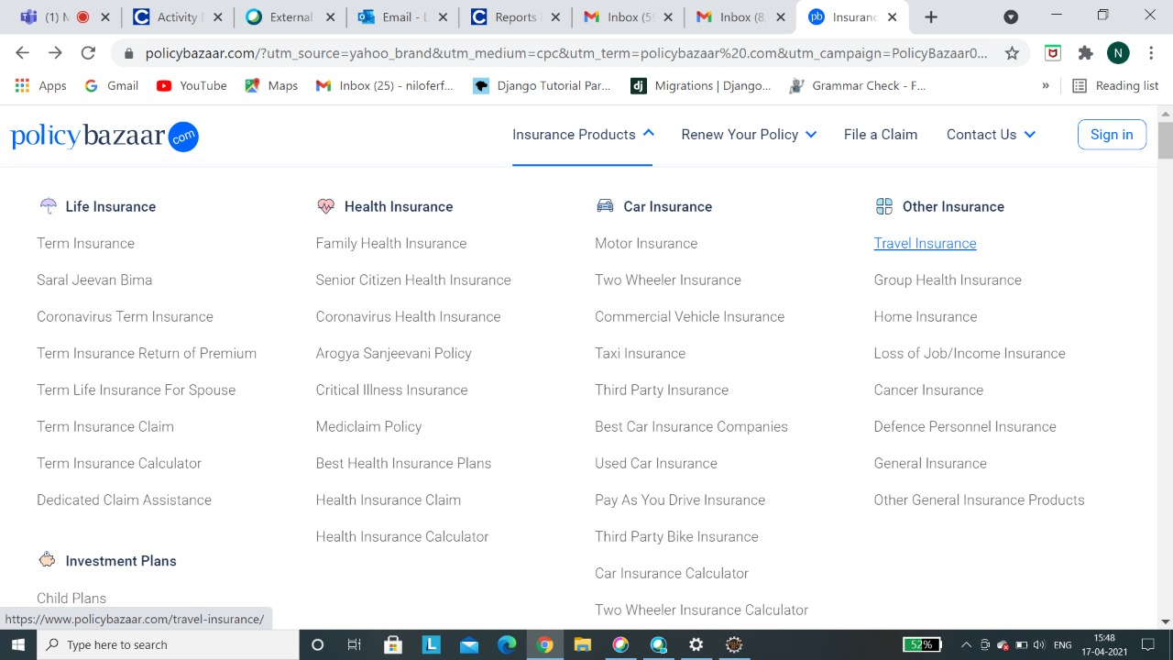

**b. Select Travel Insurance**

**Input:** Select Travel Insurance

**Output:** navigate to next page.



**c. Click on Student tab.**

1. **Input:** Select the student tab
2. **Output:** The student tab should be selected.

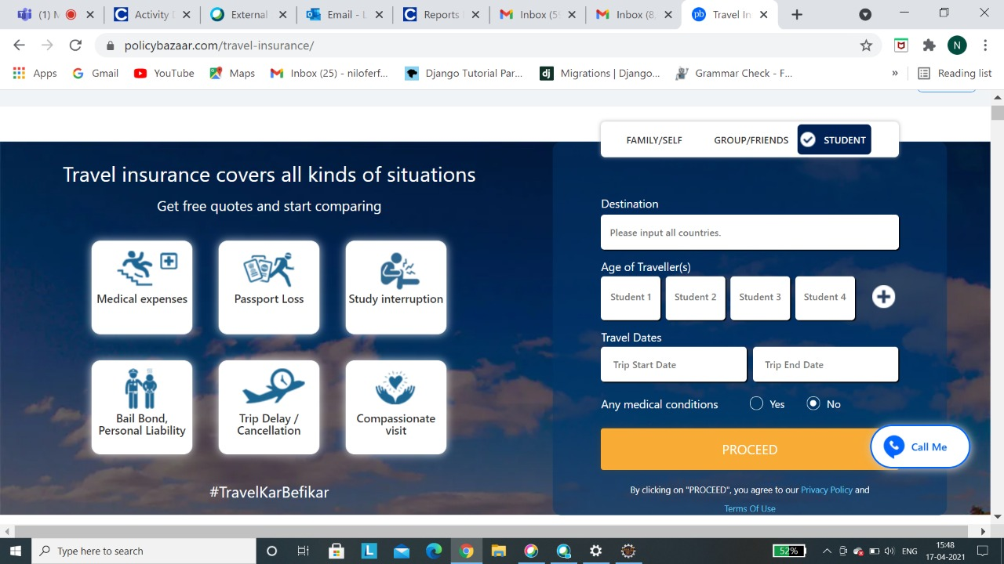

**d. Enter the details of functionalities**

1. **Input:** Entervalid details of Destination, age, Travel dates.
2. **Output:** The details are displayed.

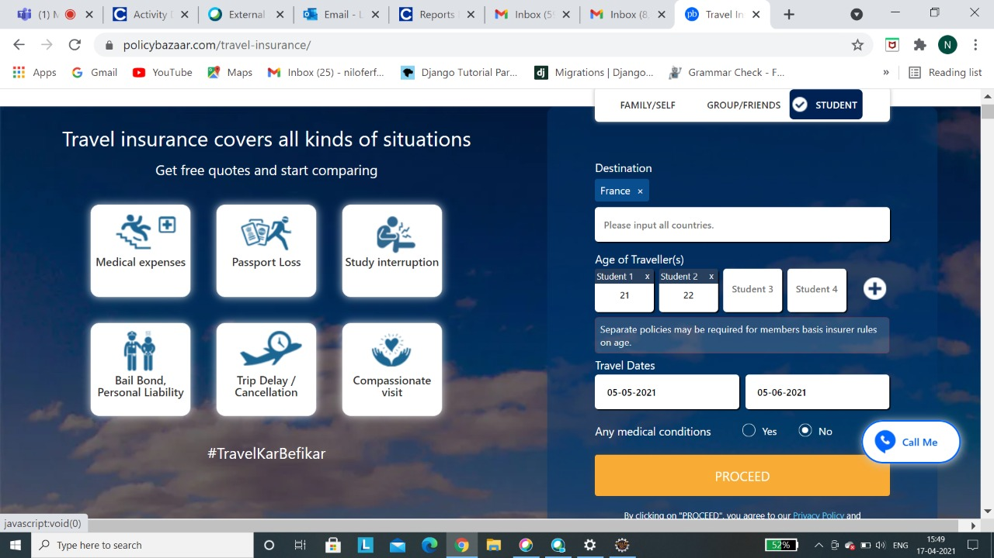

**e. Proceed button**

1. **Input:** Click the Process button
2. **Output:** Navigates to next page



**f. Enter Details**

1. **Input:** Enter the details
2. **Output:** The details are displayed.

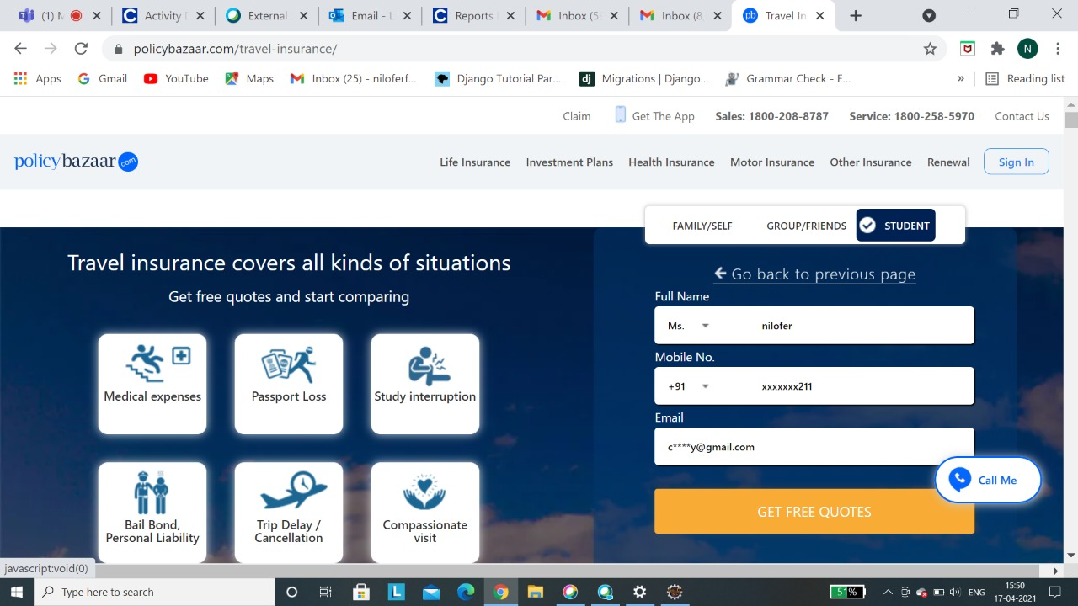

**g. Get Free Quotes**

1. **Input:** Click Get Free Quotes button
2. **Output:** Navigates to next page.

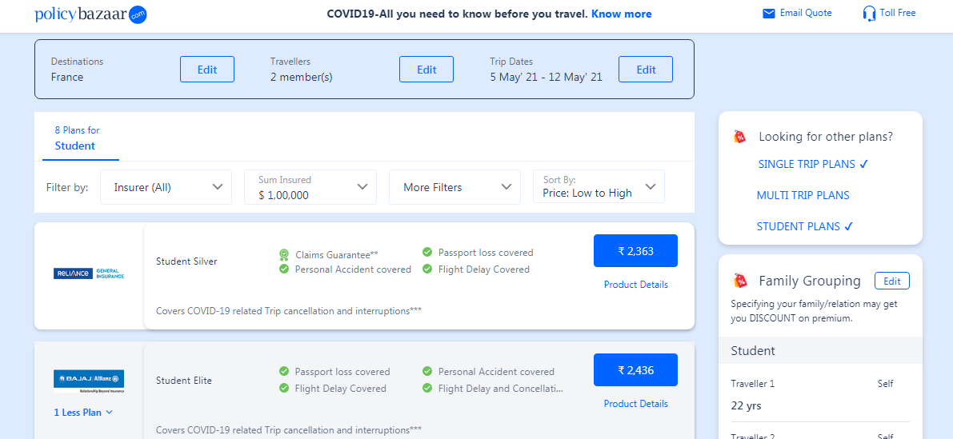

**h. Click on Sort By**

1. **Input:** Click the Sort By
2. **Output:** The drop down is displayed

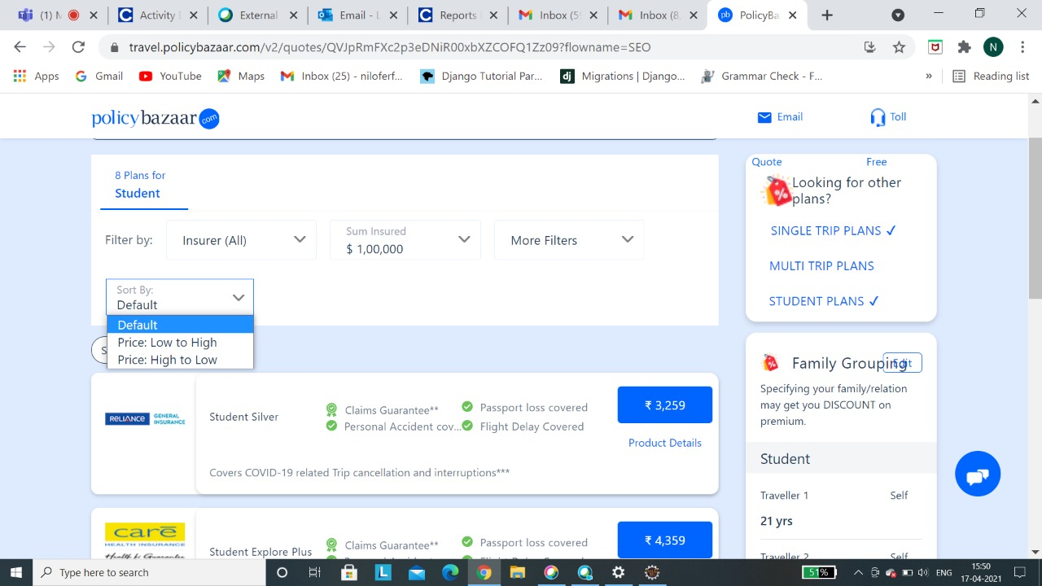

**i. Select low to high price**

1. **Input:** Select low-high price from drop down.
2. **Output:** The list is displayed successfully.

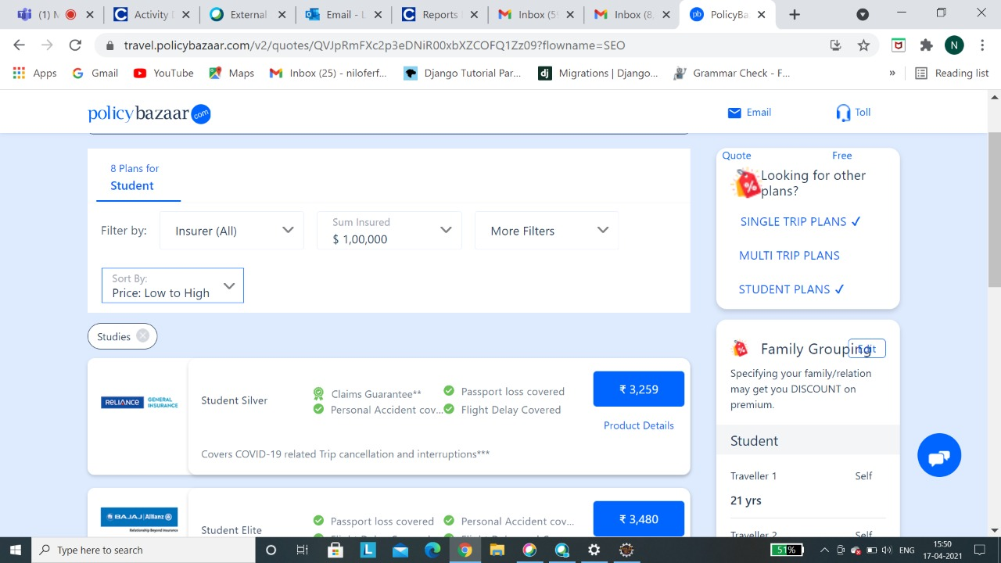

**j. Back to home page**

1. **Input:** Click the back button
2. **Output:** The home page is displayed

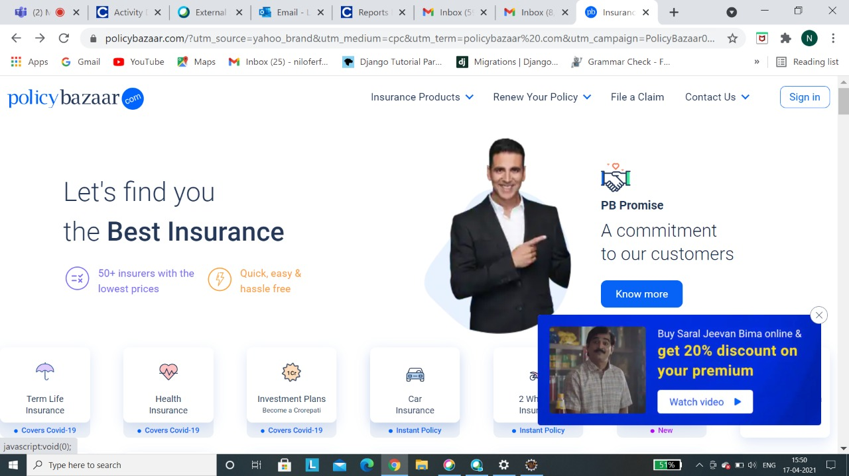

**k. Select the Car Insurance**

1. **Input:** Click Car Insurance
2. **Output:** The car insurance page is displayed

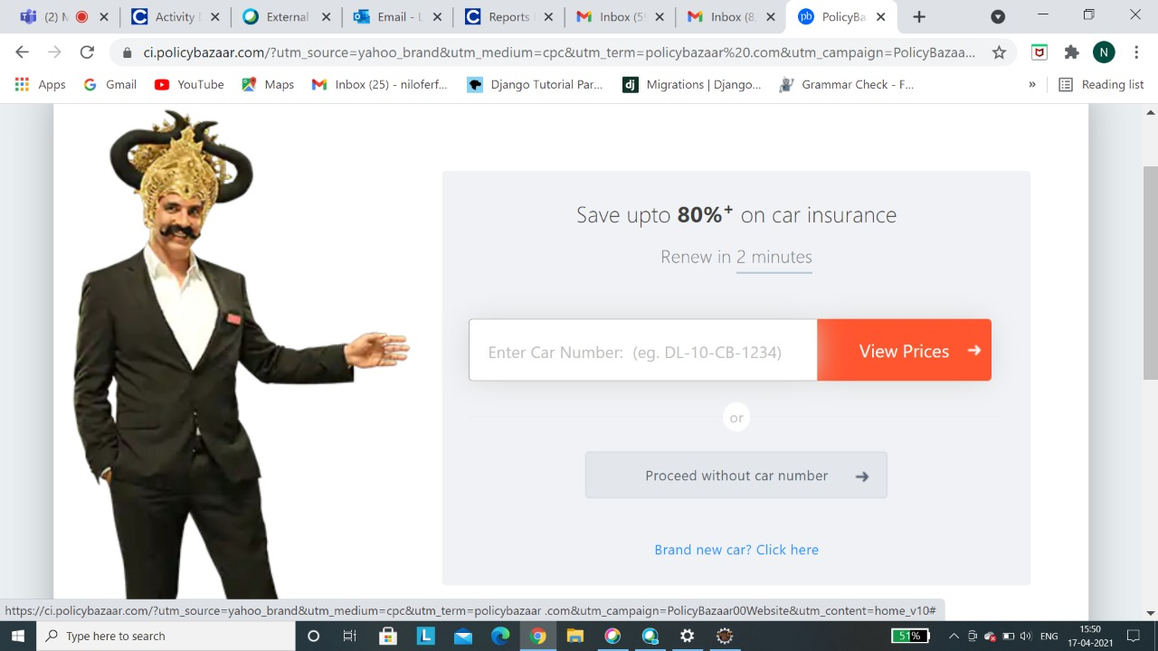

**l. Proceed without car number button**

1. **Input:** Click on proceed without car number
2. **Output:** Navigates to next page

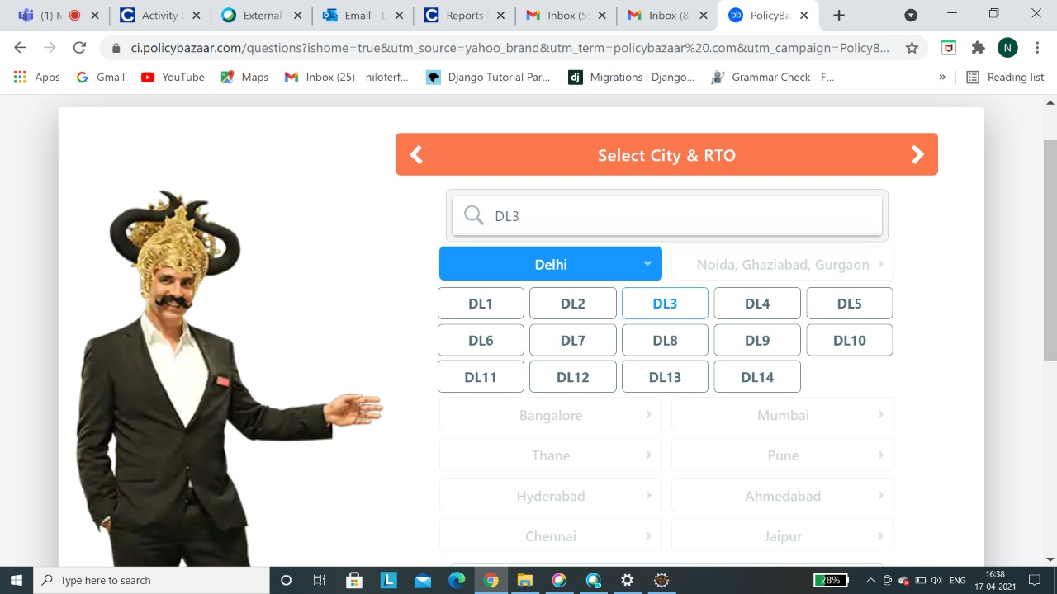

**m. Enter the details**

1. **Input:** Enter the invalid email in details
2. **Output:** Error message is displayed

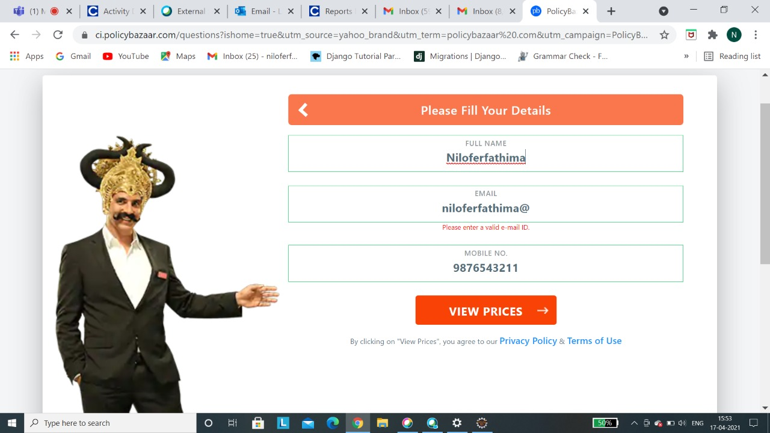

**n.View Prices Button**

**Input:**Click on view prices button.

**Output:**Navigates to new page.



**o.Capture Error Message**

**Input:**Invalid Email-Id

**Output:**Screen shot is taken.



**p.Back to home page**

1. **Input:** Click the back button
2. **Output:** The home page is displayed



**q.Select Health Insurance**

**input:**Click on health insurance

**output:**Display health insurance plans.

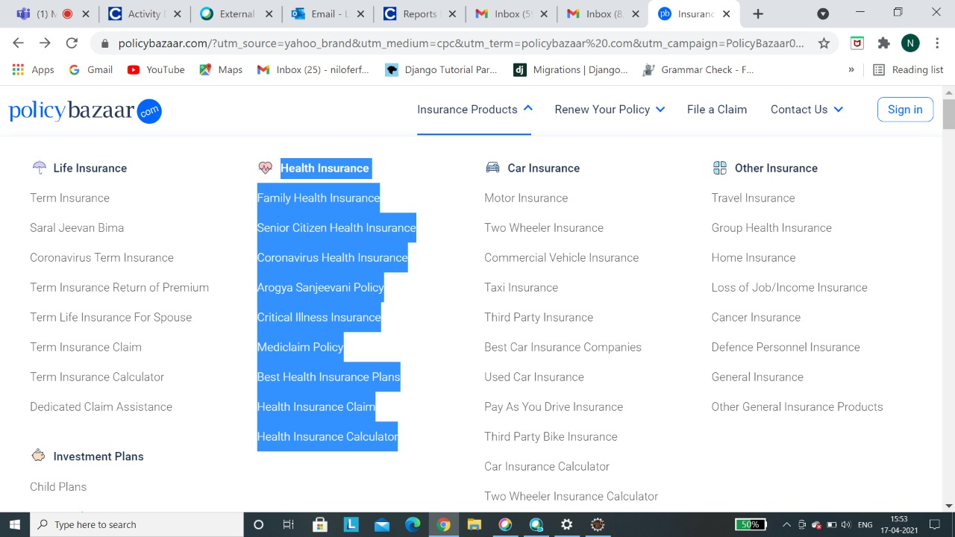

## 3.3. Performance Requirements

The system response time for every interaction conducted by the user should not exceed more than a minimum of 10 seconds. The system should provide a high performance rate when executing users input and should be able to provide response within a short time span usually 50 seconds for a complicated task and 20- 25 seconds for less complicated task.

## 3.4. Security

The system provides authorized access; hence we can only login with valid credentials. Only users with valid Mobile number and OTP can login to their respective logins. If user tries to login with invalid credentials an error message will be displayed.

## 3.5. Usability

The system provides several options which are very easy to use. Terminology is easy so, we can interact with the application very easily.

## 3.6. Other Requirements

**a. Availability:**

The system should be available for access at 24 hours, 7 days a week .Also in the occurrence of any major system malfunctioning, the system should be available in 1 to 2 working days, so that business process is not severely affected.

**b. Error handling:**

Error should be considerably minimized and an appropriate error message that guides the user to recover from the error should be provided. Validation of user’s message is highly essential.

**Appendix A. Analysis Models**

List any attached / referenced documentation such as data flow diagrams, class diagrams, state-transition diagrams, entity-relationship diagrams, etc.

|  |  |  |
| --- | --- | --- |
| **ANALYSIS MODELS** | | |
| **DOCUMENT NAME** | **DESCRIPTION** | **LOCATION** |
| FUNCTIONAL REQUIREMENT DOCUMENT | TRAVEL INSURANCE | <https://www.policybazaar.com> |
| CAR INSURANCE |
|
| HEALTH INSURANCE |
|

**DATA FLOW DIAGRAM**

**1. Data Flow for Travel Insurance**

Go to the browser

Launch the website

Select the Insurance Products

Destination

Select the Travel Insurance

Age

Start Date

Enter the details in functionalities

End Date

Enter Details

**2. Data Flow for Health Insurance**

Launch the website

Go to the Browser

Select the Health Insurance

Health Insurance plans are Displayed

**3. Data Flow for Car Insurance**

Error message is displayed

Enter the invalid email in details

Go to the Browser

Select Car Insurance

Launch the website

Select Proceed without car number Button

**Appendix B. Issues List**

|  |  |  |
| --- | --- | --- |
| **ISSUES LIST** | | |
| **ISSUE ID** | **ISSUE DESCRIPTION** | **STATUS** |
| IS_1 | In makemytrip application the type of cab option is not available so for appropriate search results of different types of cabs are displayed on the screen | Pending |

**DISCLAIMER**

Any articles, templates, or information provided by Smart sheet on the website are for reference only. While we strive to keep the information up to date and correct, we make no representations or warranties of any kind, express or implied, about the completeness, accuracy, reliability, suitability, or availability with respect to the website or the information, articles, templates, or related graphics contained on the website. Any reliance you place on such information is therefore strictly at your own risk.